


Now at NYCCE: Dry Herb Vaporization with PAX:
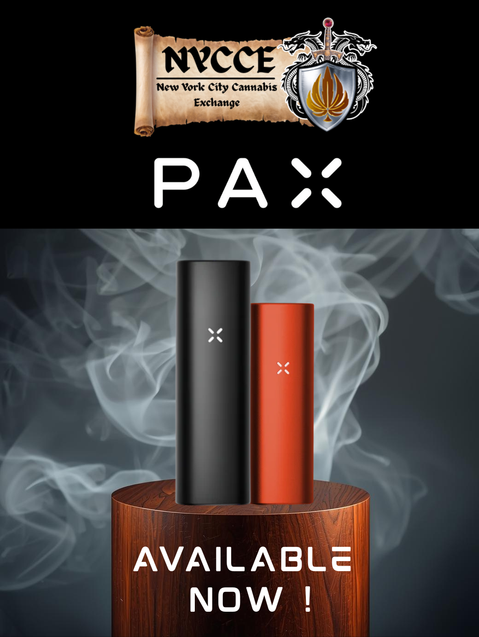

We’re excited to offer a new way to enjoy our flower—introducing PAX dry herb vaporizers! Now in stock: the PAX Mini and PAX Onyx.
PAX vaporizers use conduction heating to deliver smooth, clean,and flavorful vapor without burning your product.
- PAX Mini: Compact, discreet, and great for casual users. Features a single heat setting and small oven—perfect for quick sessions on the go.
- PAX Onyx: Ideal for experienced users. Offers four heat settings, a larger oven, and a stealth mode that reduces odor. Bonus: It also functions as a mini dab tool for concentrates.
Explore a cleaner way to consume—now available at NYCCE!

For More Detailed Information Read More About The Product Below:

