



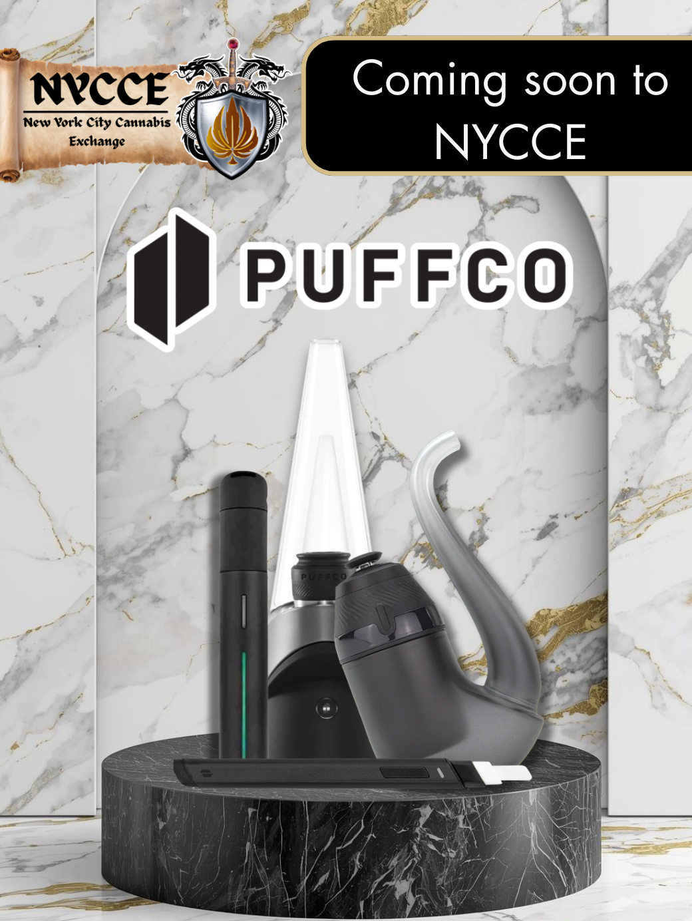
Introducing Electronic Dabbing Vaporizers at NYCCE:
Experience the Next Level of Concentrate Consumption

We’re excited to introduce a new era of vaping at NYCCE with the arrival of Puffco – a premium brand renowned for delivering cutting-edge electronic dabbing vaporizers.
Our current lineup includes three exceptional devices tailored to different lifestyles: the Puffco Peak , Proxy, and Pivot.
- Puffco Pivot and Proxy are perfect for discreet, on-the-go use. Compact, lightweight, and powered by advanced 3D ceramic chambers, these vaporizers heat your concentrates quickly and efficiently – ideal for a smooth, convenient experience wherever you are.
- For those who prefer a more powerful, at-home session, the Puffco Peak is your go-to device. Featuring an integrated water filtration system, the Peak delivers cooler, smoother, and more robust clouds. While it's less portable due to its size and weight, it makes up for it with premium performance.
Whether you're looking for convenience or the ultimate home setup, Puffco has a device that fits your needs. Visit NYCCE to elevate your smoking experience today.

For More Detailed Information Read More About The Product Below:
